Actor

Value object

Market segment

Value market

Value interface

Value exchange

Value activity

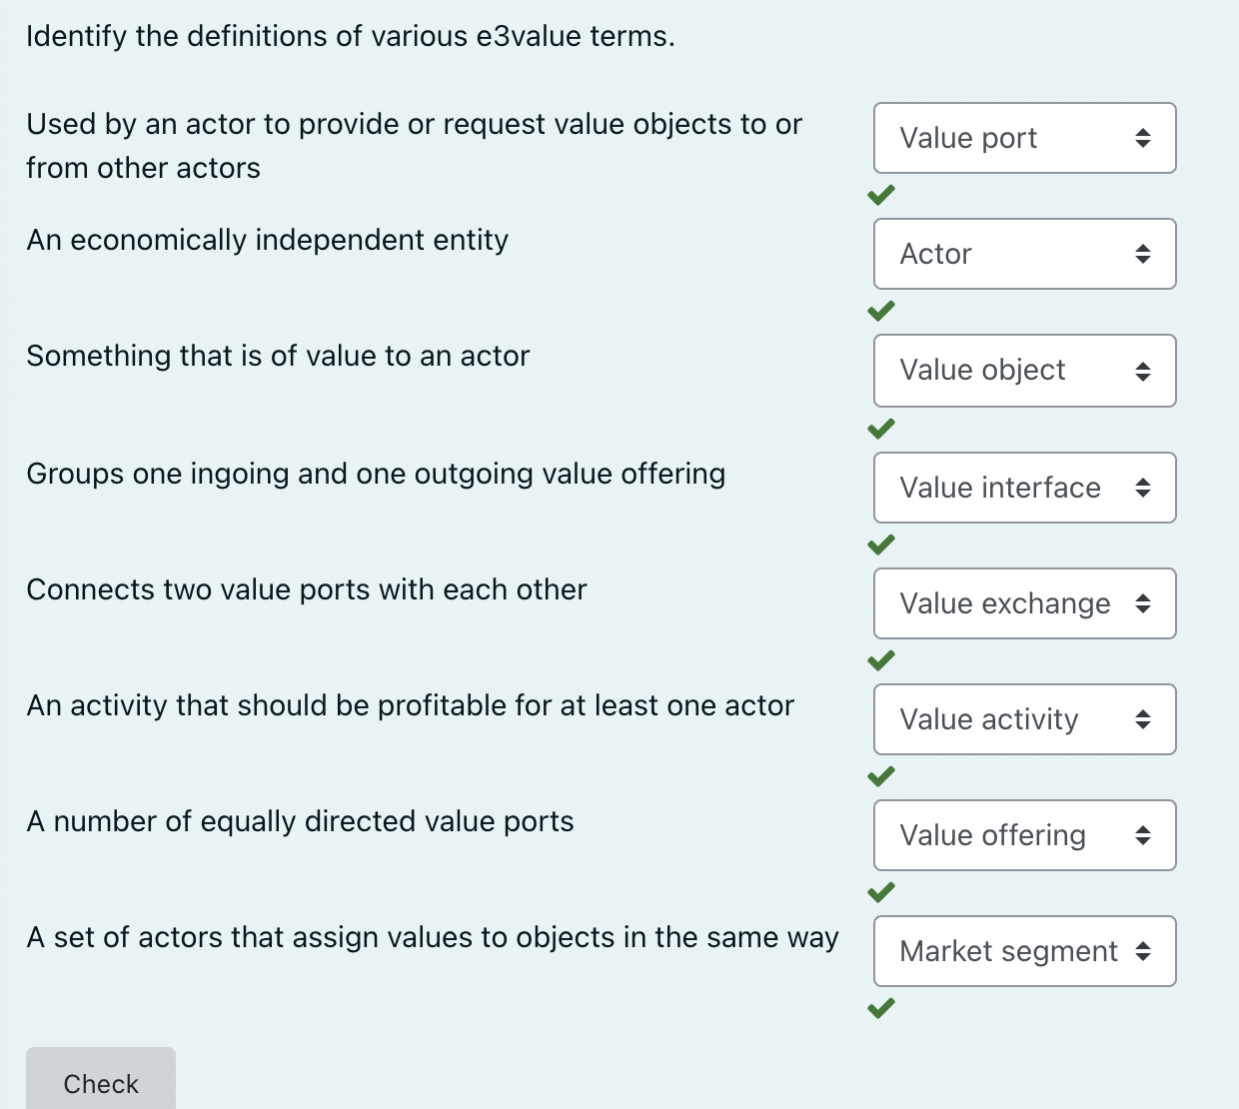

Market segments group actors with similar preferences for a certain value object

A value interface should include both in-ports and out-ports

An e3value model may include an actor A and an actor B, such that A and B are associated via several value exchanges belonging to several value interfaces

